|  |  |
| --- | --- |
| **DATE** | 1.11.2023 |
| **TEAM ID** | NM2023TMID08614 |
| **PROJECT NAME** | Create a Google business page |

Step:1 →Search (*Create google business page*) and it will show a web of ( Google business profile)

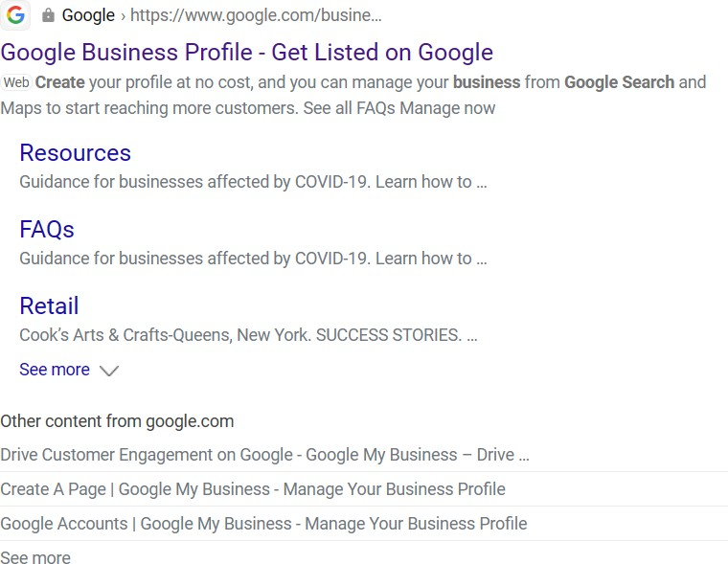

Step:2 →Enter your business name and Category of your business

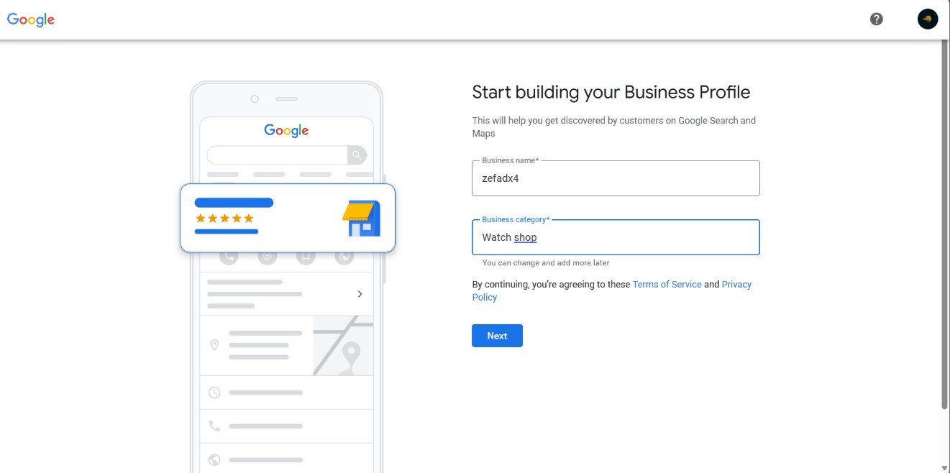

Step:3 →Enter your shop address where it located

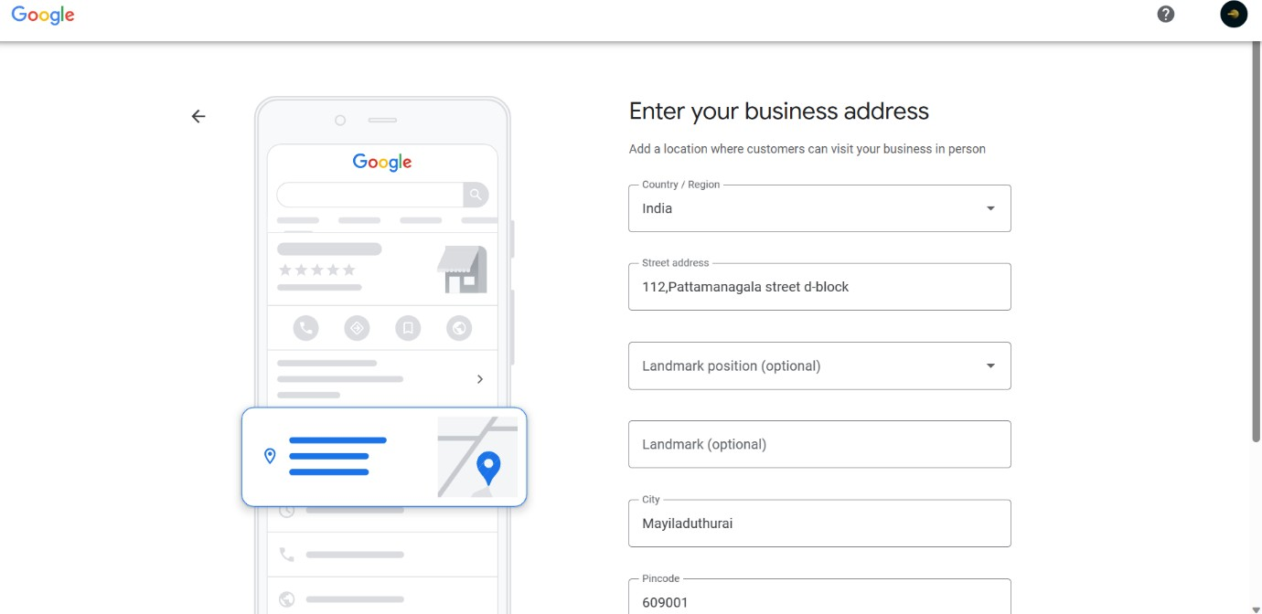

Step:4→After you give a details to that website about your shop then you need to enter your mobile number for verification or else recorded video about your business

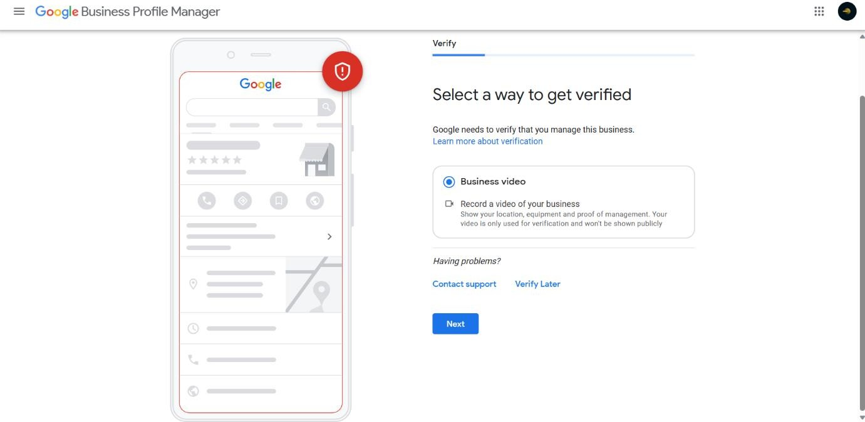

Step:5→Add open and close time of your shop

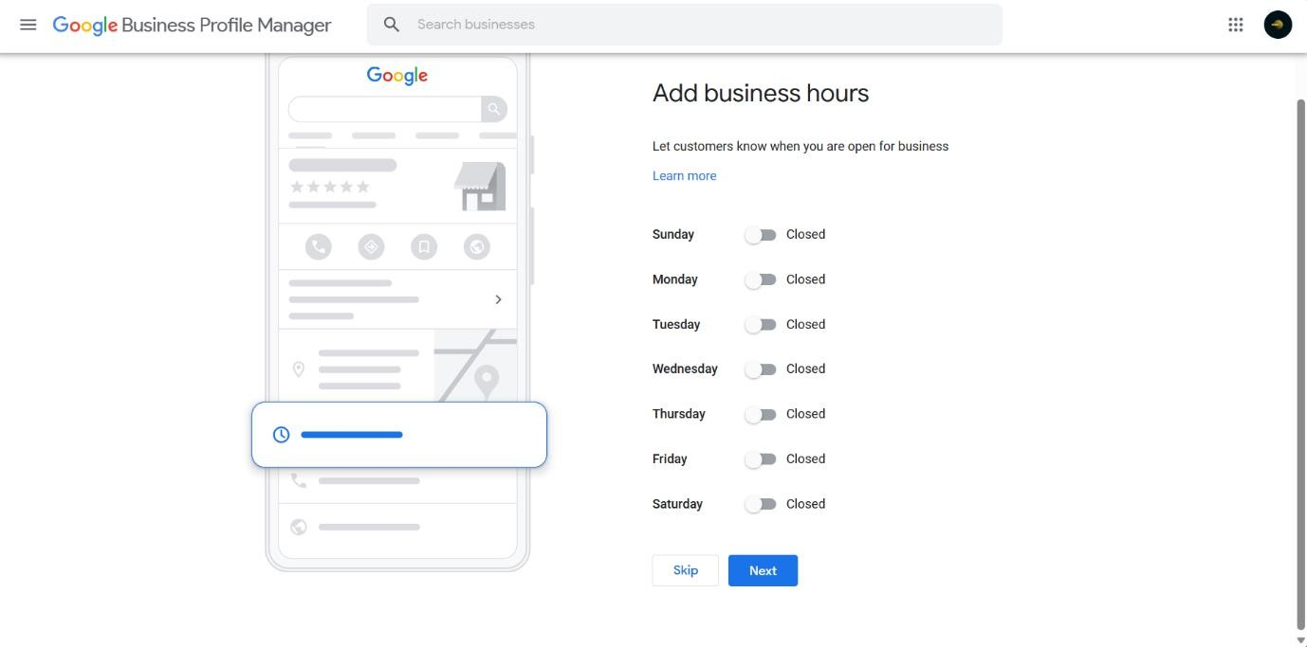

Step:6→Add your shop images

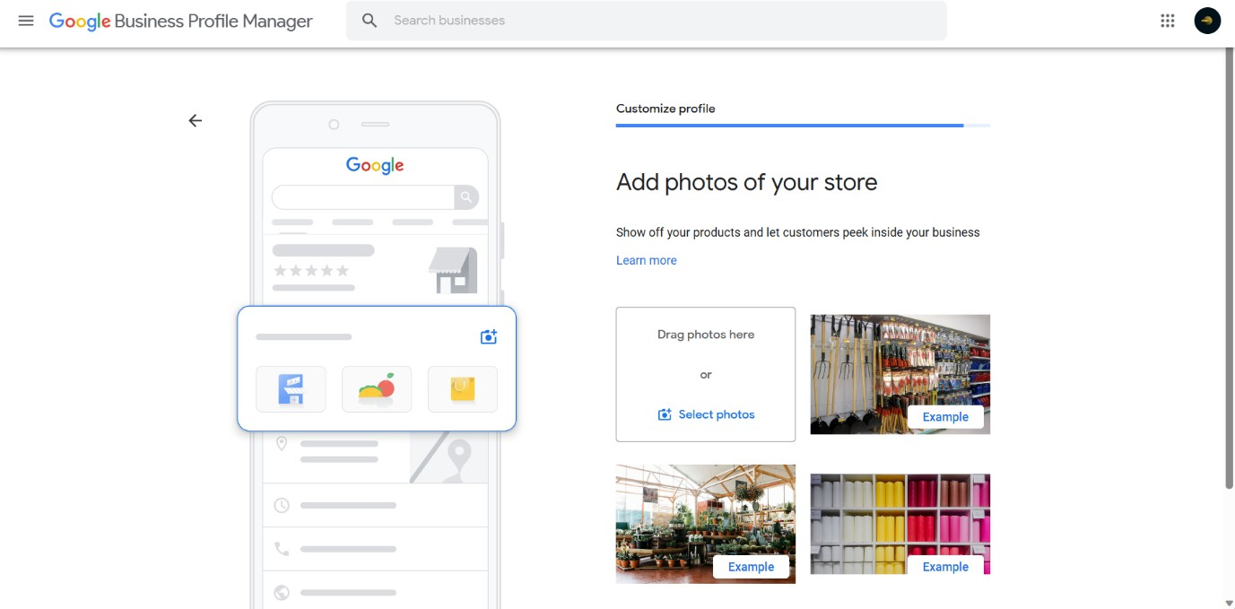

Step:7→After you completed the verification and all details about your shop

Step:8→Search your shop name on google, it will shows your shop and the details

